(Part 2)

**IBM**

<-aka International Business Machines Corporation->

(Day 5)

On the way, when I was imaging another wonderful trip to a big world-famous company, Frank Gao cleared his voice and told us that we were heading to Stanford and one of his friends who works at IBM as a Chief Technological Officer (aka CTO) with PhD of science and engineering would come and give us a presentation and that we were welcome to call him Dr. Zhao. “That still sounds great!” I was just as pumped as every one else on the bus.

This time, we arrived at a different place on the campus. It’s more like a cabin for vacation than

a classroom.

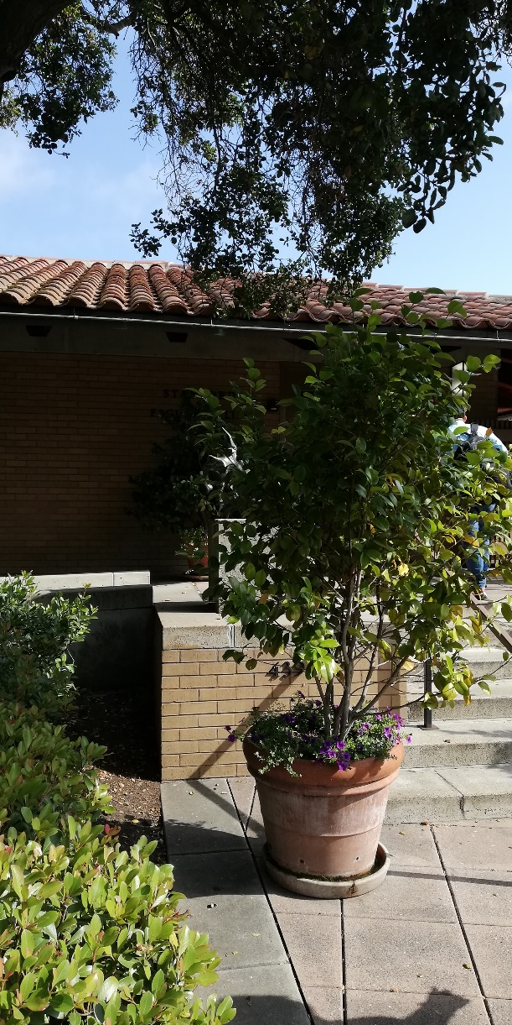 

The environment was so nice and quiet here. On the wall it read “Stanford Faculty Club”. Just as I wanted to ask about it, Frank Gao said to us “This is the place where the professors and executives of Stanford come for lunch usually. Some of them are even awarded with Noble Price and we are going to have lunch here today. In the morning, we will learn more about IBM, then we have lunch and, in the afternoon, Tamara will continue the *Design & Innovation* lesson with you guys.” I was so ready for this!

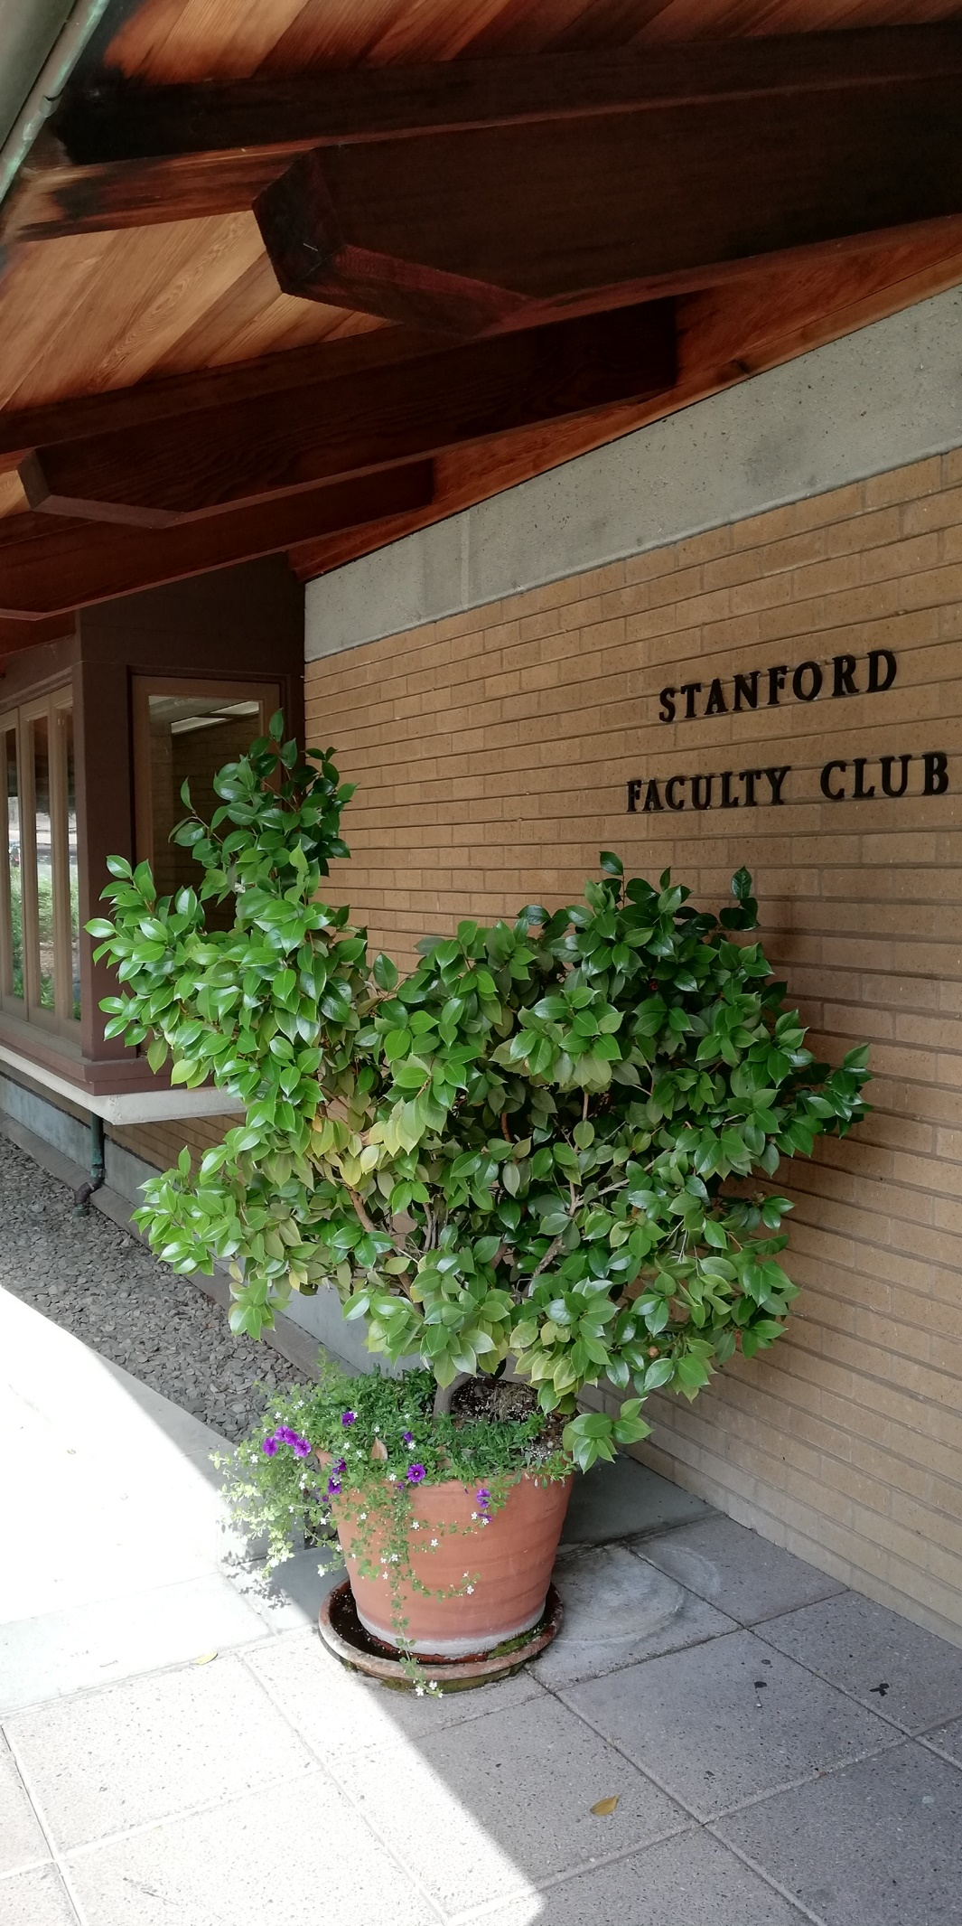

Dr. Zhao is a tall and slim gentleman with think dark hair, wearing metal frame glasses and you can always see a slight trace of warm smile on his face when he speaks and all these portraits that he is a knowledgeable person. He introduced us about himself such things as he came from Suzhou, China; After college, he came to work at IBM in California, and now he is mainly in charge of database management.

* Define IBM

What is IBM?

Some say IMB is the technological product developer; IBM is the ancestor of IT. IBM is definitely mentioned in every CS (Computer Science) textbook used by every education institution all around the world.

Some say IBM is about digital sales because it was IBM that first came up with the idea of digital business (not Jack Ma, he just surfs on the tip of the wave that was started by IBM)

IBM slogan “encourage people to use digital devices to do business, change the traditional ways of doing business” When people do business online, IBM can sell them computers, online services and make money. “Another slogan started by IBM is “Smart City”. In the past, when we say a person is intelligent, we mean the person knows a lot of information, and can respond quickly to questions. Nowadays, we have added another meaning to the word ‘intelligence’. We mean how well a person can utilize a machine. So, an intelligent city is not about how smart the governors are, but how well the city functions in terms of the transportation, internet coverage, etc.” Dr. Zhao said.

* What is IBM and its focus?

1. Innovate and develop technological products (software and hardware)
2. Global technological services, adding values to the products {takes up >50% of total revenue}

(not just sell you the products, but also help you make the most of them)

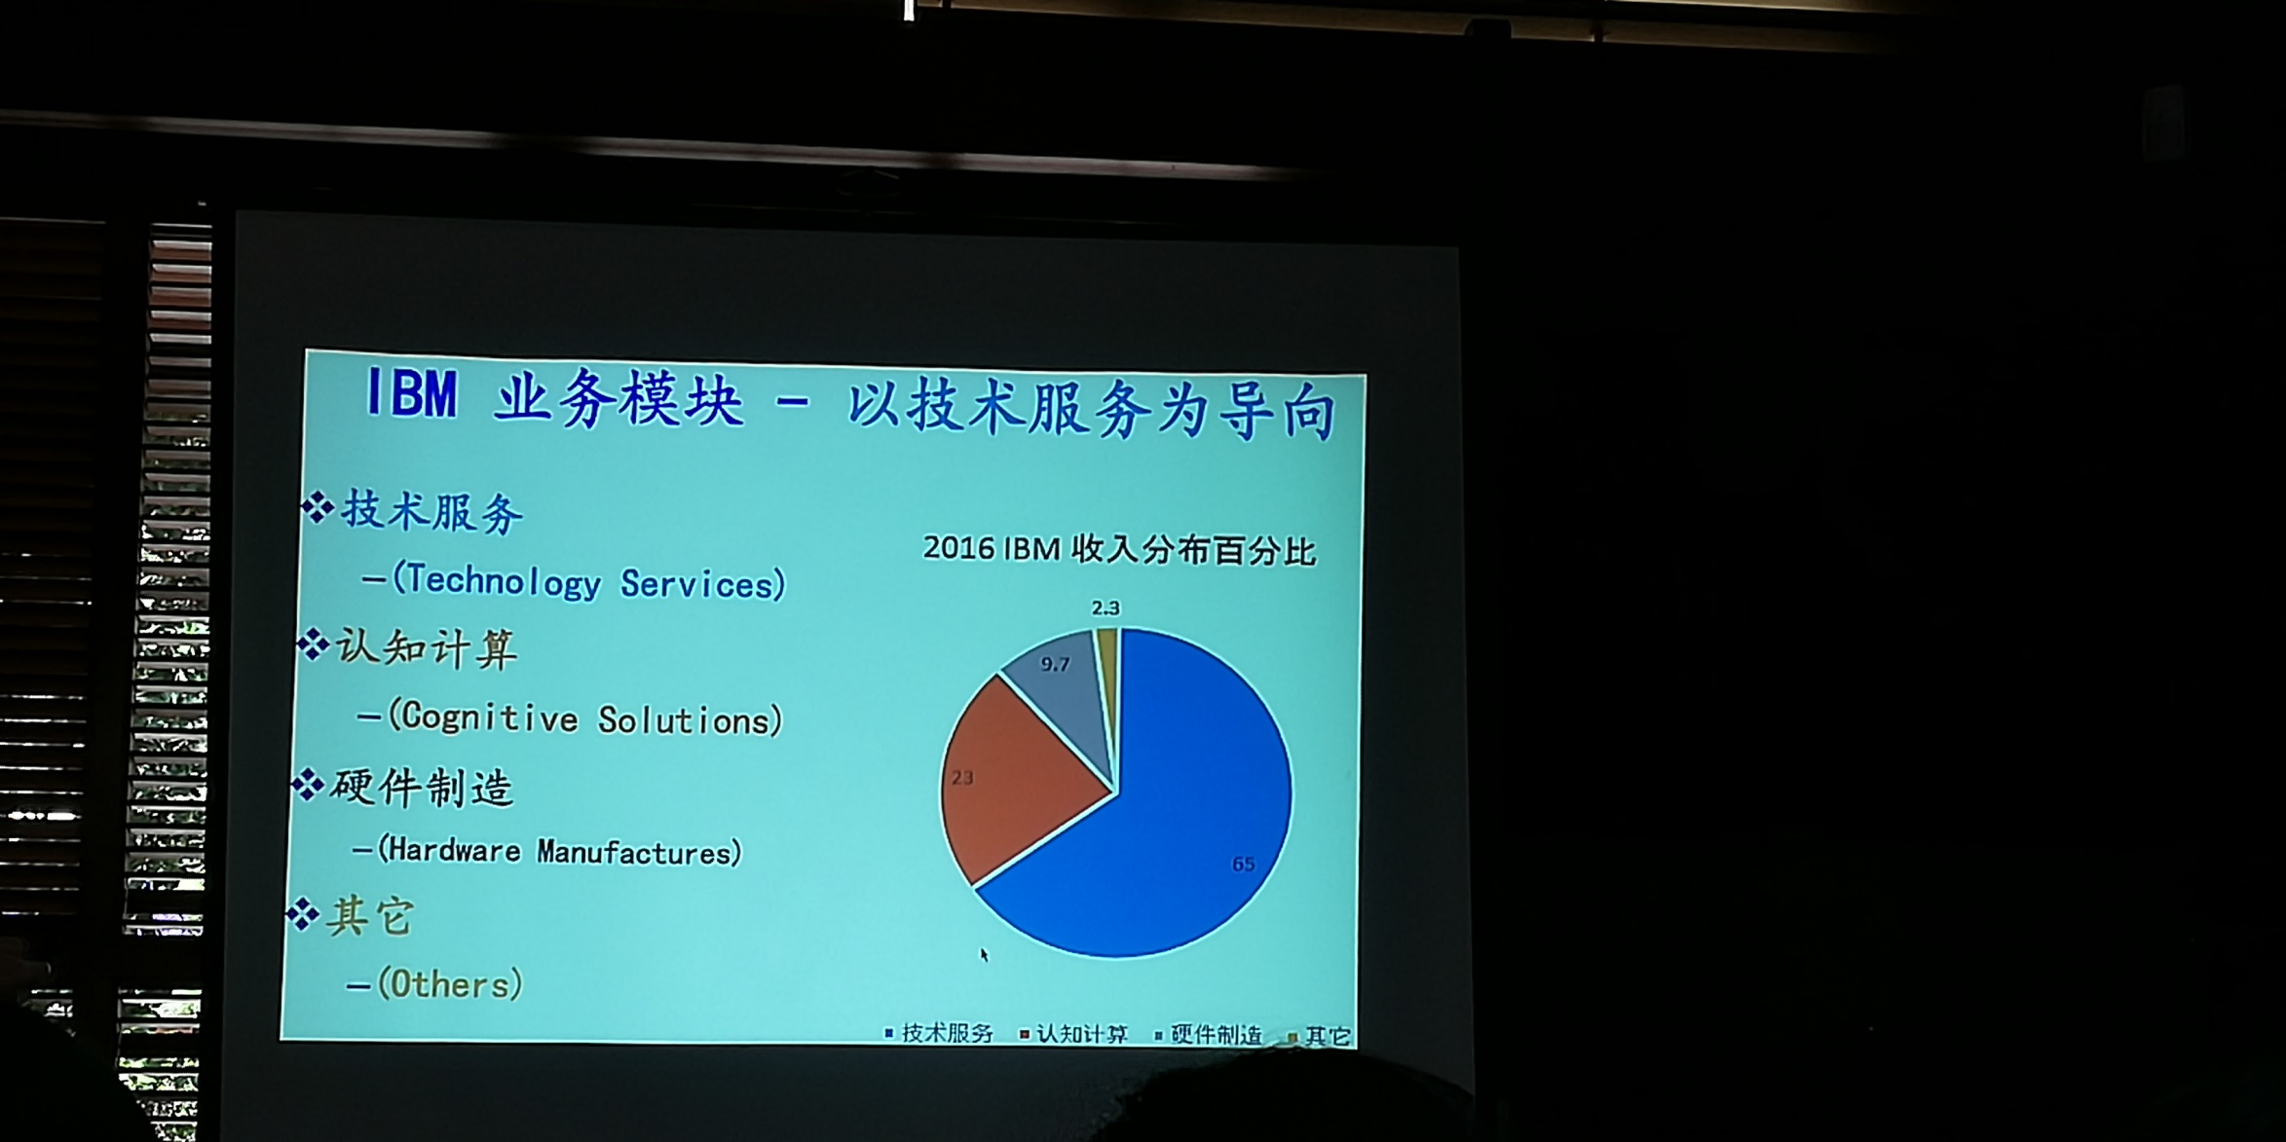

* Facts about IBM

1. Its headquarter id located in New York State
2. IBM has around 400,000 staff (the largest IT company)
3. 1911, direction: office automation products

Back to the early days, people use a slip of paper with numbers of it to calculate staff’s working hours. Basically, when the staff came to work in the morning, a person would punch a hole on their paper and when they clocked off, their paper would be punched with another hole. Thereby, their working hours could be calculated by the distance between the holes and they would receive their corresponding wages. Later, IBM develop punched-card machine so the working hours calculation no longer needed to be done manually. Nowadays, we are still using this calculating method on our computers. We know that computers calculate in 0 and 1, and 0 just represents the hole. Thus, the IBM punched-card machine was a great invention.

Nowadays, there are two trends in the development of computers.

1. We make computers smaller and smaller.

From the room-sized machine to desk top to lap top to cell phone to wearable devices to tiny devices that can be injected into our vessel even to smaller devices that can be wired to our neuros.

1. We make bigger and stronger computers

Super computers for massive data calculation usually used in military, weather forecast calculation and satellite control.

1. In 1990s, IBM started the trend of separated network, cloud computing and came up with the idea of ‘online business’.
2. In 2000, IBM first came up with the idea of ‘intelligent earth and intelligent city’.

This is the general history of IBM. Without such a history, there wouldn’t be such an IT world that we live in today. Up till now, we have AI (Artificial Intelligence), block chain, cloud computing and maybe there’ll be more new words in the future. However, the only thing doesn’t change is the computing model behind all these, in other words, everything is about computing. As a result, people start to realize that data is becoming as important as natural resources. Without data, world cannot even function as it does. Maybe for individuals, it’s just one day without Internet, and they still can survive spending a day in the mountain, but for corporates, it’s life or death.

* Strategies

1. Serve the premium clients

IBM mainly manufacture big machines for big clients such as big corporates, national banks and government. Usually, there are two ways for us to tackle with massive amount of data. One way is to form a cluster of individual computers to improve the computing power as a whole system. The other way is to use super computers with thousands or even more CPU on them and that brings strong computing power. These machines are difficult to manufacture and are more expensive but they compute faster and bring more accurate result.

Dr. Zhao added “Some people ask would IBM, at some point, start manufacturing cell phones to compete with Apple, Huawei? Based on what I just explained to you, this is not likely to happen. IBM’s target clients are always the big clients not individuals.” “previously, U.S. government bought a large machine from IBM for two hundred and eight million dollars. The machine allows them to do the simulation of nuclear experiments on the it, which is a significant thing to the environment and people’s safety. For this, IBM was awarded with American science and technology research and development award in 2009. This an example of what technology can do for the society. Machines are becoming increasingly powerful, for example, a super machine called “blue light” can read a million books in just one second. We should not only make machines smarter, but also try to figure out how to let machines better serve our society. For medical care, machines provide more accurate diagnoses than human does; For law, AI machines give 100% fare judgement because they analyse the case only based on data and rules whereas a human judge may be influenced by other factors like emotion. However, the reason why we create these machines is not to replace people, but to release people from their heavy workload with the help of machines. Another interesting topic is that should we feel threatened by Artificial Intelligence? Would one day evil robots take the world from us? To answer these puzzles, let’s first talk about how AI works. AI is smart because we teach them things, write functions for them, put data into the machines and based on all the information, they can do smart things that human does. However, up till now, we still haven’t figured out how our brain works and machines can never think like us unless we tell them how. So, Artificial Intelligence shouldn’t be our real concern.”

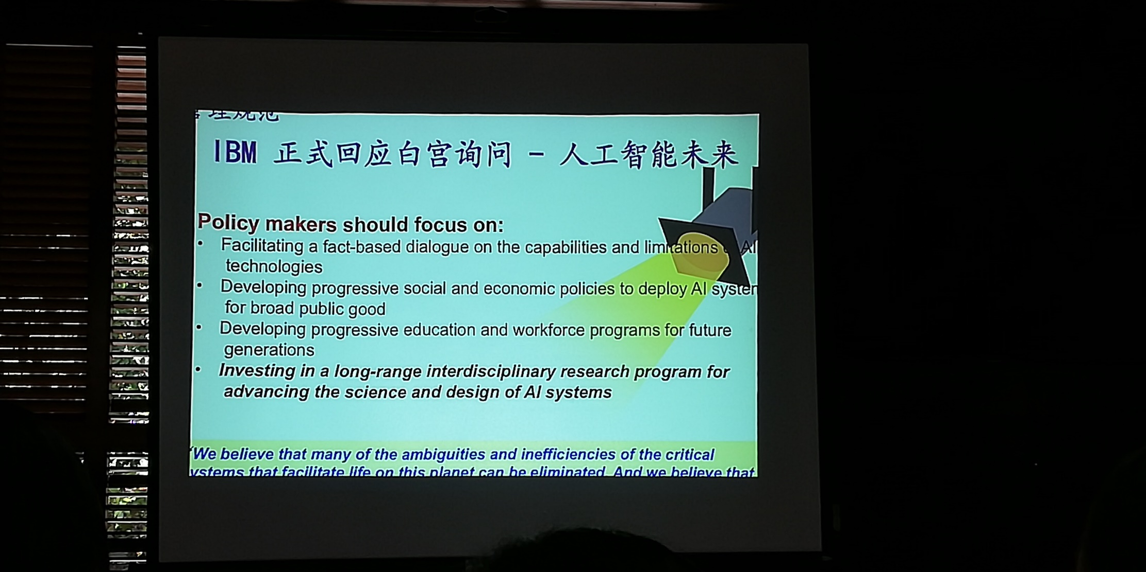

1. Develop data storage technology

“For individual, when your USB’s capacity is full, you can buy a new one to save more data. But, for corporates, the amount of data they receive everyday is unconceivable and losing any bit of data means losing great business opportunities. Some may say ‘we can simply build more database servers so all the data can be saved.’ However, the problem is, if we just rely on today’s data storage technology, we would run out od space on earth for data storage one day. There is actually a secret data center located in a desert here in America and its expands at the rate of forty to fifty football courts size every year. In every building, there are hundreds database servers; in each server, there are eighty to hundred disks and each disk storages massive amount of data. So now we are working on new data storage technology. There is an interesting phenomenon that when we turn on a computer or a cell phone, we have to wait dozen seconds until it functions. This is because the data is being transmitted from the disk to the memory and the process takes some time. We all know that disks have larger data storage capacity and can permanently storage the data but they transmit the data very slow, while memories transmit the data much faster but can only storage the data temporarily. We are trying to develop a memory that can storage data forever so that the data storage space can be dramatically reduced and computers will function faster by 50%. Another direction we are working on is to upgrade data storage to atom level. What that means is using one atom to represent the data ‘0’ or ‘1’. The challenge part is how can we precisely move round an atom? If we can do that, then we can keep record of the motion trail of the atom and based on that, we can represent ‘0’ or ‘1’ at atom level, which means we can use a storage device in the size of a matchbox to storage the same amount of data that takes a football filed sized data storage center.’’

* Profit chain

“Just like in nature, we have food chain. In business, we have profit chain. For IBM, the manufacture of products is at the low end of the profit chain while the technological services are at the high end of the chain and the profit you make could be ten times more. This is why now around 50% of IBM’s revenue comes form technological services, while only 10% of that comes from selling computers. The prices of products only go down as time goes by, while the value of technological services increases when opportunities occur. However, this doesn’t mean some start-ups should do business in this way. IBM has been selling products as core business for a hundred years and only based on the solid technological products business can we expand to technological services business. For young companies, they need to build their own identity based on solid product business while regarding the technological services as their goal.’’

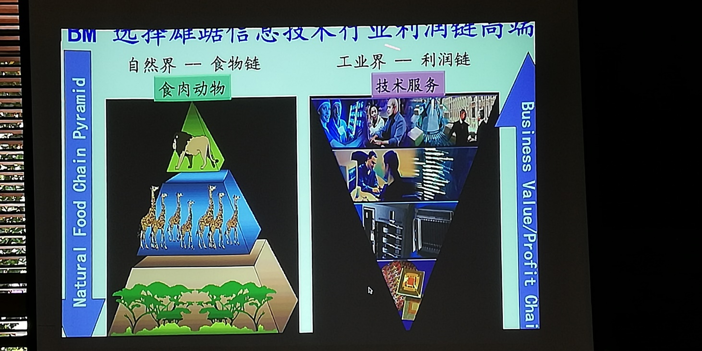

At the our desperate request, Dr. Zhao spent another thirty minutes talked to us about “Blockchain” such concept. I took down several key points as following.

Block chain:

1. Electrical account book
2. Separated storage (in different cities, countries)
3. Connected by Internet
4. No center

Dr. Zhao’s presentation skill was amazing. In the two-hour lecture, I felt like I’d learnt more things than I could learn in two years outside. What a fruitful lesson!

*Strategic Innovation& Design Thinking* class

(part 2)

“Today’s lesson is divided into three parts. First, we’re gonna talk about the courses taught at ME310 (Mechanical Engineering center at Stanford). Then we’re going to visit the ME center and see the works of students. Finally, by 3:00pm, I hope you guys can be all back here and we will do some group exercises.” Ms. Carleton said.

“Ok, Let’s talk about ME310, you may remember I’d mentioned this course on Tuesday. It is a graduate editing course at Stanford university. ME is in the Mechanical Engineering department and 310 is master’s level class. This a full year class, three quarters, from September to June. This class has been taught for fifty years since 1967 and the premise has largely been the same – student teams working on design challenges form companies, which is why the slide says the class is an ecosystem for design innovation because you have students working on real world problems. They are learning soft skills such as time management, supply management and more, and this helps them in their career. Now let me share hoe the class is structured. You start with a student team, usually four students per team. Then the students are under the direction of the teaching team which include faculty, student assistants as well as coaches and others.”

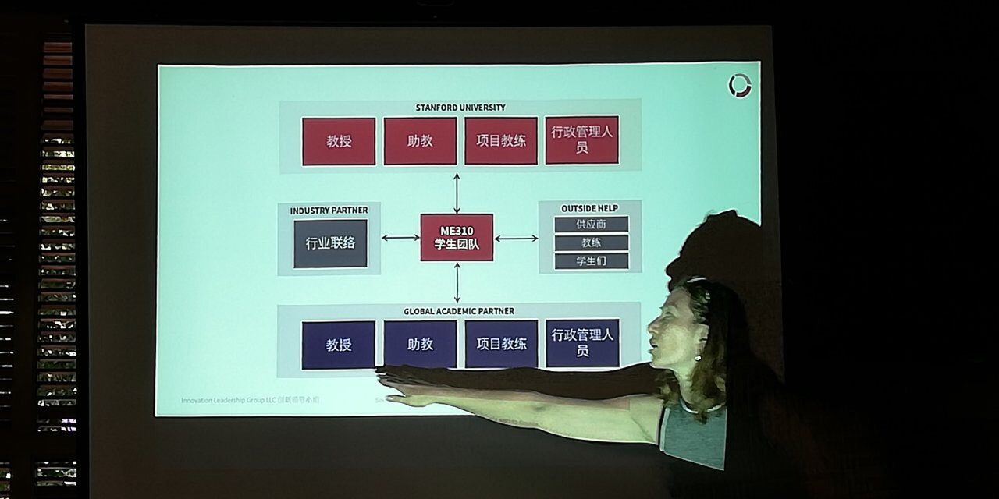

“Then the students work with Corporate Create Zone as often a team of people from companies. The students get a budget for their project and that covers their travel, and mostly their prototyping supply for the year. And the student teams use the funds, and also call favors to get extra expertise, meaning they may pay their roommate to do some programming for them or to do graphic design, but it's a great experience because they have to figure out how to go from a design challenge to functioning prototype in the end. And decades ago, the teaching team realized that the students can benefit from learning about distributive design, so every Stanford

student team was partnered with the student teams at another university which also had a teaching team as well. So, suddenly, the team became double, not four people but eight. The companies range across industries, countries and problems. So, you can see some companies from all over the palces in the world that have sponsored students over the years from the graph.” Then she demonstrated us a design process chart.

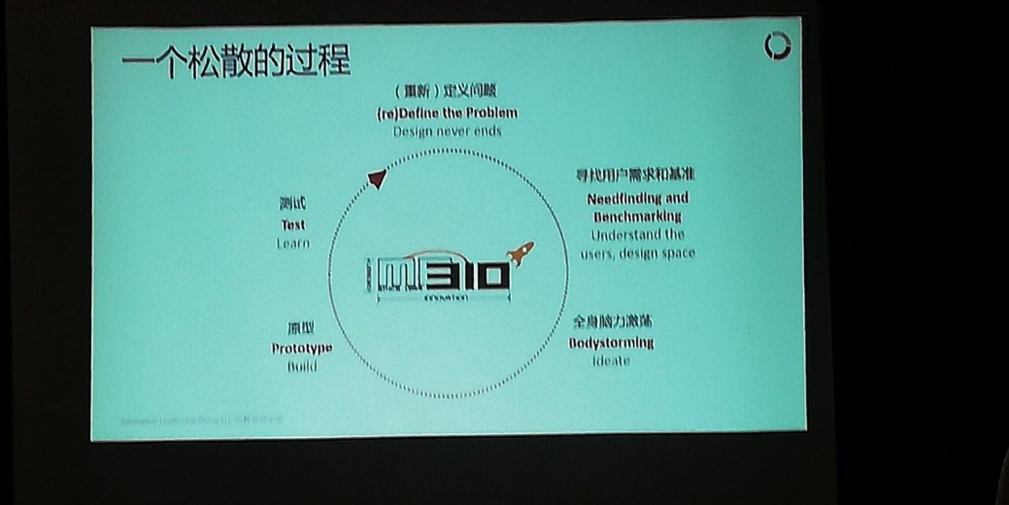

“The students follow this general process through the year. They start with design problem, benchmark. This is full body, brainstorming; building prototype, usually multiple prototypes; testing. And what you will see is the final functioning prototype this afternoon.”

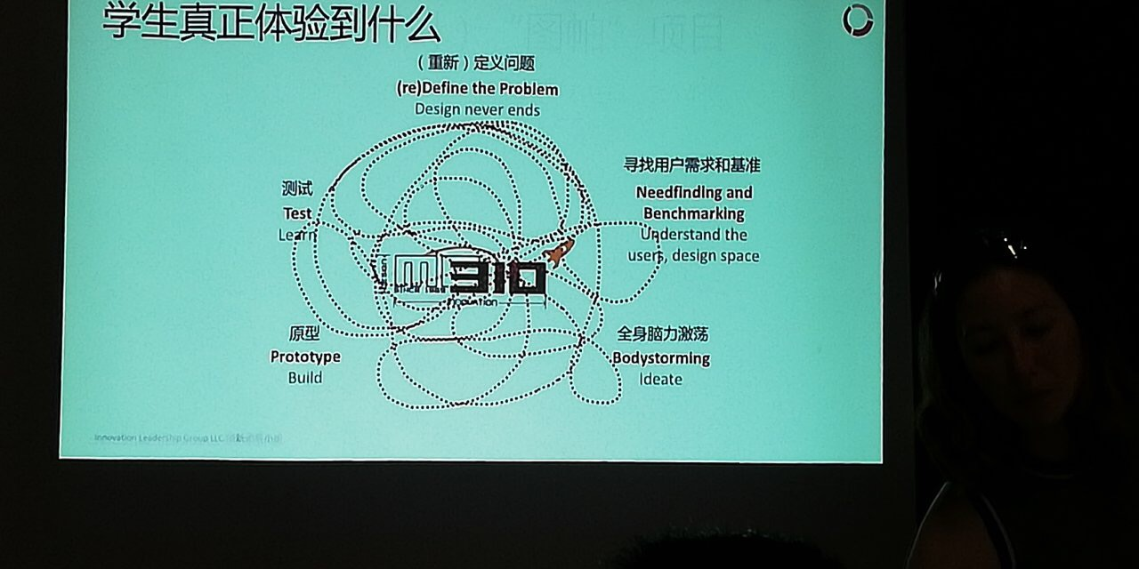

What do students experience

“Now this is what we have as the lose process. This is what the students really experience. So. Let me share one project in particular. This was actually not done by Stanford team but a furnish team from Aston University.” Then she played us a fifteen-minute long video showing how the team went through the process over and over again until they made the final product. “so that’s what students often go through and you’ll have a chance to go through this year’s show case called EXPE. EXPE is the first four letters of experience. You’ll experience the design show case. EXPE is made up of several classes from the department of Mechanical Engineering, but the biggest show case comes from this class this year. This is the brochure for just the ME310 projects, and I’ll hand the copies to you later. So, during the experience, you’ll find all these teams starting now to present their demo and share the stories.”

ME310 EXPE brochure 2018

